Implementation of Wireless Sensor System for Soil NPK analysis using Runge-Kutta Method

# Akshay Tekam

Department of Computer Engineering MIT Academy of Engineering Alandi, Pune 412105

Email: [tekamakshay11@gmail.com](mailto:tekamakshay11@gmail.com)

# Vinod Rawool

Department of Computer Engineering MIT Academy of Engineering Alandi, Pune 412105

Email: [vinodraw](mailto:vinodrawool00@gmail.com)[ool00@gmail.com](mailto:ool00@gmail.com)

# Shridhar Rakshe

Department of Computer Engineering MIT Academy of Engineering Alandi, Pune 412105

Email: [shridhar9298@gmail.com](mailto:shridhar9298@gmail.com)

# Rachana Somwanshi

Department of Computer Engineering MIT Academy of Engineering Alandi, Pune 412105

Email: [rachanasomw](mailto:rachanasomwanshi97@gmail.com)[anshi97@gmail.com](mailto:anshi97@gmail.com)

Prof. Santosh T. Warpe Department of Computer Engineering MIT Academy of Engineering Alandi, Pune 412105

Email: [stw](mailto:stwarpe@comp.maepune.ac.in)[arpe@comp.maepune.ac.in](mailto:arpe@comp.maepune.ac.in)

***Abstract*—As agriculture plays a major role in economical development of India, so we need to adapt new technologies for Precision Agriculture. The productivity ratio of farm cultivation in India is relatively lesser than other countries. The low produc- tivity results in incompetent supply of food to overall population of India. To enhance productivity and profit margin, adaptation of new technologies can help us at great extent. We propose the system with Wireless Sensor Network for NPK monitoring using sensor nodes. This system present study and analysis of Wireless Sensor Network that can be applied in agriculture for automated farming.This will help the end users like farmers for the better knowledge of agriculture practices to be applied for distribution of fertilizers.**

**Index Terms: Wireless Sensor Network, Precision Agriculture, Soil Nutrient, Crop Productivity, Runge Kutta Method.**

1. INTRODUCTION

Agriculture is one of the most important source of liveli- hood. Agricultural growth is considered as the backbone of countrys economical development. An agricultural monitoring system provides environmental and controlling services for field which leads to crop growth in an optimal status. The technology utilization would be allowed for remote monitoring and real time measurement of factors such as plant growth con- dition including temperature, humidity, atmospheric pressure, soil moisture, water level,NPK values. Wireless sensor system for soil NPK analysis is nothing but a distribution of sensor nodes on crop field and gathering information to base station for analysis [2].

1. *Wireless Sensor Network*

Wireless Sensor Network(WSN) is currently most widely used technology to create own Personal Area Network.WSN is collection of Sensor Nodes that can monitor physical parame- ters such as temperature,humidity,soil moisture,light intensity etc.Sensor is most important component of WSN.It has wide range of applications such as in agriculture,industry monitoring and in military for enemy detection etc .In agriculture WSN is used to monitor the soil moisture,temperature and humidity

in real time to maintain proper temperature,water level and moisture in agriculture field[3]. In our case it monitors the value of NPK fertilizer.

1. *NPK Fertilizer*

Soil is a very complex medium that consists of vari- ous organic matter,minerals, micro-organisms, water and air. Various studies have shown that soil fertility is declining in many farmlands due to insufficient fertilization.Use of more than required fertilizers results in groundwater pollution or harmful accumulation of chemical in the soil. The goal of this experiment is to optimize fertilization depending on a crop’s need and soil properties to reduce the amount of fertilizer in soil without diminishing yield [7].

1. *Architectural Design*

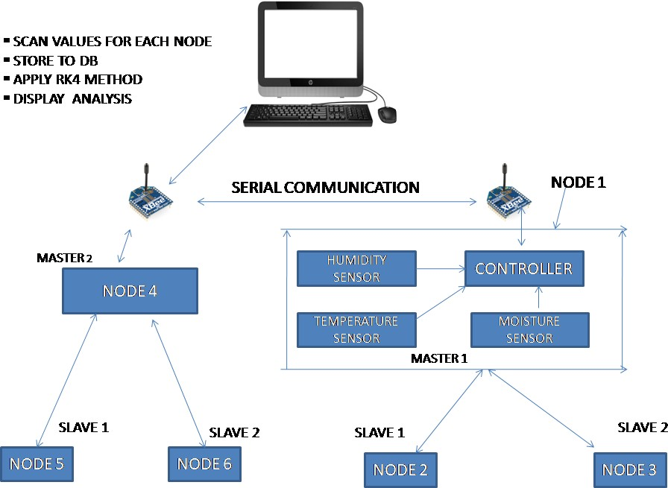

Fig. 1. Architectural Design

1. MATHEMATICAL MODELING

*P* = *{* S, E, I, Su, Fu *}*

S=Start Point

E=End Point,it analyses data. I=set of Input,I1, I2,..., In

Su=success condition data received properly

Fu= Sensor failed to read values, data not received properly. System Description:

* + Input: water+Fertilizer/liter

Output: x is the optimal value of fertilizer that must be provided to different crops.

*•*

Success Conditions: All Hardware components con- nected and deployed correctly.

*•*

Failure Conditions: Any Hardware error can cause a big problem as we are using multi-hoping technique every nodes connection should be done properly.

*•*

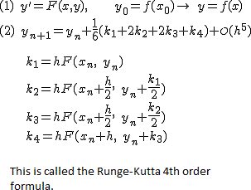

Fig. 2. Runge-Kutta 4th order Formula

1. MULTIHOP ROUTING IN WIRELESS SENSOR NETWORK

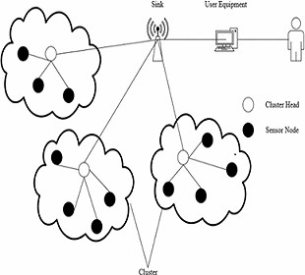

Fig. 3. WSN Muti-hop Routing

1. LITERATURE REVIEW

Arpit Rawankar,*et. al.*, [1] . Detection of N, P, K fertilizers in agricultural soil with NIR laser absorption technique. In this paper they have taken a sample of soil under test and they mixed it with four different types of fertilizers such as KNO3, TSP, (NH4)2SO4, NPK in some particular concentration range. By determining the molecular geometry, bond strength,atomic masses using IR laser beam which passes through the sample, we can determine the concentrations of N, P, and K. Their main purpose is to maintain the amount of fertilizers in the field.

Rajinder kumar,*et. al.*, [2]A wireless sensor network based low cost and energy efficient frame work for precision agri- culture. In this paper authors have proposed a framework for precision agriculture. They have used low cost, high accuracy, and high range sensor for real time monitoring the crop field. They deployed temperature sensor, moisture sensor, and humidity sensor and connected with Xbee for wireless communication. Here they have used ac submersible water pump which required 165-250V AC which is capable of lifting water up to a height of 2m. G. Sahitya, *et. al.* [3] This journal shows the availability and usability of wireless sensor system in agriculture areas. The use of WSN are tremendous. WSN collects the data from the field using ZigBee modules. They have shown the real time data based on several characteristics such as temperature, humidity, moisture, etc. The architecture proposed in this paper contains set of sensors called sensor nodes, base station and one central station, here the base station sends the sensed data to the central station.

G. Deepika, *et. al.*,[4] Wireless sensor network in precision agriculture: A survey. In this survey paper they also explained about the existing methods and new methods and the devel- opment of WSN. Plant monitoring with the image processing and sensor networks using Field Programmable Gate Array (FPGA) based control is the new method.

Linh Nguyen, *et. al.* [5] Soil organic matter estimation in precision agriculture using wireless sensor networks. This journal shows the problem of predicting soil organic matter in agriculture field using collected information by low-cost network of mobile, wireless and noisy sensors. They have also proposed a Gaussian processes using which they can predict the environment phenomena at any unobserved points.

L.E.D. Smith, *et. al.*,[6]A comprehensive review of con- straints to improved Management of fertilizers in China and mitigation of diffuse water pollution from agriculture. This paper addresses this issue through a comprehensive Review of the interrelated factors that contribute to excessive use of fertilizer in China. Political, policy, structural and behavioural barriers to improved fertilizer management and mitigation of DWPA are identified, along with priority agendas for policy and further research.

Pierre-Marc Deluxe, *et. al.* [7] Tracing the evolutionary path to nitrogen fixing crops. Nitrogen is a key element for plants and is a limiting nutrient for plant growth. Although nitrogen is the commonest element in the atmosphere, few plants can access this un-reactive pool. Thus, current agricul- tural practices rely on the application of large quantities of chemical fertilizers that represent reactive forms of nitrogen capable of boosting crop productivity. Strategy to overcome the use of chemical fertilizers in agriculture would be to engineer such nitrogen-fixing symbioses into non-legume crops.

Michael Udvardi, *et. al.* [8] Authors of this journal depicted Nitrogen as a primary source of environmental pollution via gaseous and leaching losses. Due to massive use of fertilizer especially synthetic N-fertilizer which has the use of around 100 million metric tons each year which doubles the flux of N. Authors also suggested some strategies to these problems. The solutions could be greater use of symbiotic nitrogen fixation in legumes, use of association nitrogen fixation in non-legumes, ect.

Rakhesh Devadas *et. al.*,[5] Effect of stripe rust on the yield response of wheat to nitrogen, The Crop Journal. In this journal they tried to explain the effect of stripe rust on crop areas response of wheat. The Rusts are the most basic constraints in wheat production all across the globe. Stripe rust, also called yellow rust . It is the most damaging disease in the wheat growing areas in the world. The disease requires cool and humid climatic conditions and lower optimum temperature for its development.

Fei Xiong, *et. al.*,[6] Effect of nitrogen fertilizer on dis- tribution of starch granules in different regions of wheat endosperm, The Crop Journal, wheat is one of the three major grain domi- nating agricultural world today. It accounts for majority of food products used for human diets.This paper shows the effect of nitrogen fertilizer on distribution of starch granules in different regions. The quality of wheat based food products and the processing of wheat is strongly related to the composition of proteins and starch. Wheat grain proteins is an important trait and plays a crucial role in forming a strong, cohesive dough that will retain gas and produce light baked products. Wheat is preferably grown for bread and other our products because of its supreme baking performance .

1. EXISTING SYSTEM

Due to Globalization the climate is changing which directly affects the health of crops and crop productivity is reduced and this results in many problems for the farmers. To increase yield and to maintain quality of food,it is important to analyze the NPK values for crops at an early stage which is not possible in case of manual monitoring. In the rural areas, the farmer can analyze the growth of crops and conclude what proportion of fertilizers is supposed to be used. But the issue is that the proportion cannot determined in an early stage. There are many existing systems which are used to determine the NPK values using different methods. Newtons Forward Difference Method is used for distribution of fertilizers to crops.

The Identification steps involved are: Setup sensors and nodes:

*•*

Placing all the sensors such as Master and Slave in

the field at predefined points. Using NPK sensor to determine the NPK values.

Image Acquisition and Analysis:

*•*

Capture the image of NPK sensor where we are getting combine values of NPK.

Sending wireless signals:

*•*

Captured image of NPK sensor is now sent to the base station.

Analysis of NPK values:

*•*

Combined values are separated out and compared with the standard values of NPK for given crop.

1. CONCLUSION

Using this project user can monitor field data from remote location.Technology in agriculture helps to improve the crop yield as well as it reduces the labor cost and time. Using Wire- less Sensor Network we can make optimum use of resources and get maximum profit.

ACKNOWLEDGMENT

It is great opportunity for us to thank all the great eminent personalities who helped us to outright the work. The authors acknowledge with thanks to...

Prof. Santosh T. Warpe Department of Computer En- gineering MIT Academy of Engineering Alandi, pune.

*•*

Prof. Manish Giri Department of Computer Engineer- ing MIT Academy of Engineering Alandi, pune.

*•*

REFERENCES

1. Detection of N, P, K fertilizers in agricultural soil with NIR laser absorption technique Arpit Rawankar ; Mayurkumar Nanda ; Hemant Jadhav ; Prem Lotekar ; Rahul Pawar ; Libin Sibichan ; Akshay Pangare 2018 3rd International Conference on Microwave and Photonics (ICMAP) Year: 2018
2. A wireless sensor network based low cost and energy efficient frame work for precision agriculture Rajinder Kumar Math; Nagaraj V Dhar- wadkar 2017 International Conference on Nascent Technologies in En- gineering (ICNTE) Year: 2017
3. Designing a Wireless Sensor Network for Precision Agriculture Using Zigbee G. Sahitya; N. Balaji; C. D Naidu; S. Abinaya 2017 IEEE 7th International Advance Computing Conference (IACC) Year: 2017
4. Wireless sensor network in precision agriculture: A survey G. Deepika;

P. Rajapirian 2016 International Conference on Emerging Trends in Engineering, Technology and Science (ICETETS) Year: 2016

1. Soil organic matter estimation in precision agriculture using wireless sensor networks Linh Nguyen; Sarath Kodagoda 2016 14th International Conference on Control, Automation, Robotics and Vision (ICARCV)

Year: 2016

1. L.E.D. Smith, G. Siciliano, A comprehensive review of constraints to im- proved management of fertilizers in China and mitigation of diffuse water pollution from agriculture, Agriculture, Ecosystems and Environment, 209:15-25, 2015.
2. Pierre-Marc Deluxe, Guru Radhakrishnan and Giles Oldroyd, Tracing the evolutionary path to nitrogen fixing crops, Current Opinion in Plant Biology, 26:95- 99, 2015
3. Michael Udvardi, Eoin L. Brodie and William Rileyb, Shawn Kaeppler, and Jonathan Lynch, Impacts of agricultural nitrogen on the environment and strategies to reduce these impacts, Procedia Environmental Sciences, 29:303, 2015
4. Rakhesh Devadas, Steven Dorfer, David Backhouse, David. Lamb, Eect of stripe rust on the yield response of wheat to nitrogen, The Crop Journal, 2:201-206, 2014
5. Fei Xiong, Xurun Yu, Liang Zhou, Jing Zhang, Yanping Jin, Dongliang Li,ZhongWang, Effect of nitrogen fertilizer on distribution of starch granules in different regions of wheat endosperm, The Crop Journal, 2:46- 54, 2014
6. Effects of variety and fertilizer nitrogen on alcohol yield, grain yield, starch and protein content, and protein composition of winter wheat. Daniel R. Kindreda, Tamara M.O. Verhoevena, Richard M. Weightmana,,

J. Stuart Swanstonb, Reginald C. Aguc, James M. Brosnanc, Roger Sylvester-Bradleya 2007.